STEP 3 A SILENCE THAT SPEAKS VOLUMES
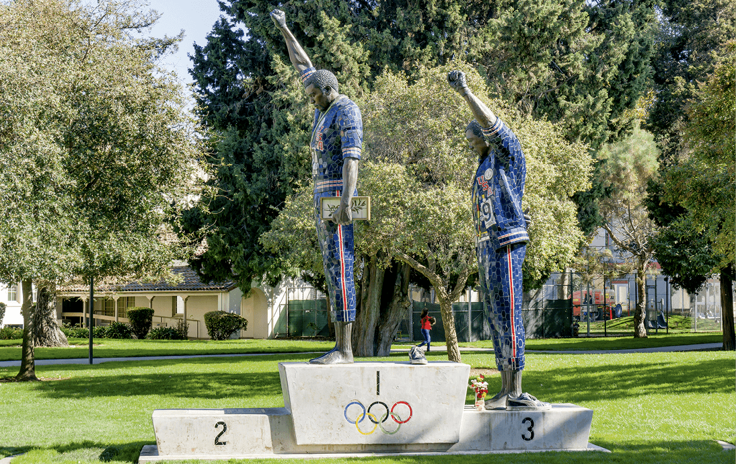
Victory Salute, statue of the 1968 Olympics Black Power Salute by Rigo 23, 2005.

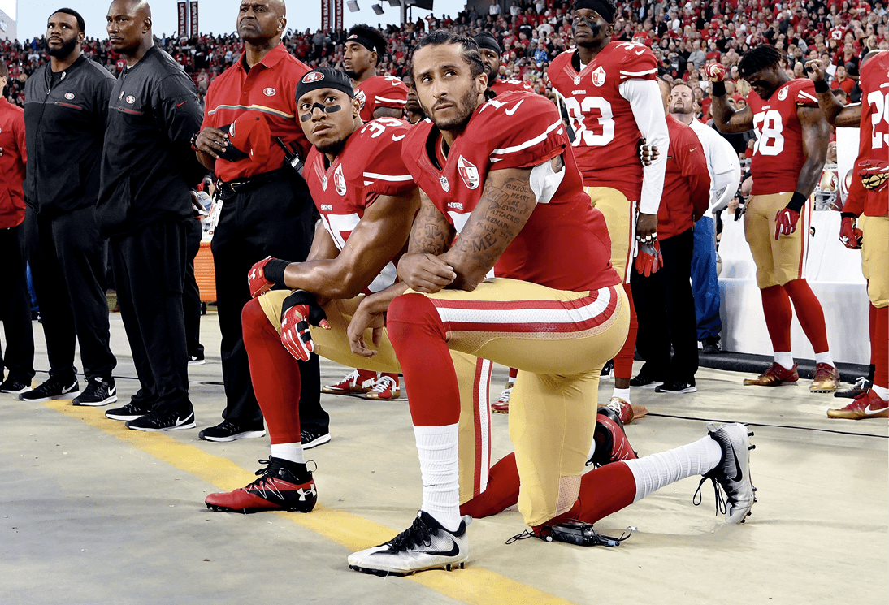
Eric Reid and Colin Kaepernick kneeling during the national anthem, 2016.

VIDEO: Iconic Olympic protesters honored at White House, CBS Evening News, 2016.
https://www.youtube.com/watch?v=n9ZSY7JCsxg&feature=youtu.be
VIDEO: Taking a stand by bending a knee: How Colin Kaepernick started a movement, Al Jazeera English, 2017.
https://www.youtube.com/watch?v=-V3OtQwLpdw&feature=youtu.be

Exercise 1: Choose one photo and one video
- Using the picture and the video, sum up who these men were, and how their action became significant.
- How do you feel about their action? Why?

Exercise 2: Share your findings and learn about the other documents
- What are the common points between these people? Justify your answer.
- Was it an effective means to denounce the situation? Why or why not?

