STEP 1 MAKING HISTORY
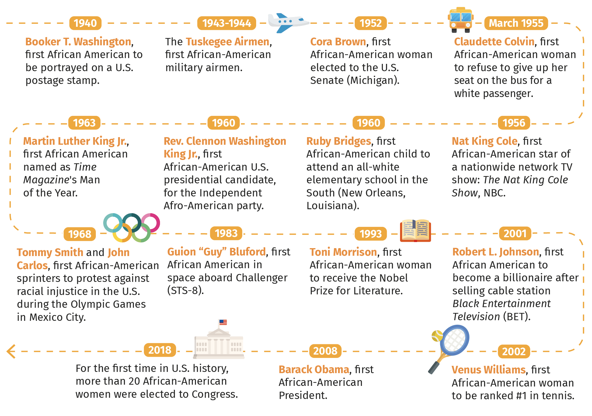
Exercise 1 : Look at the timeline and answer the following questions :
- Look at the dates and the names. What do these people have in common?
- Which achievement is the most outstanding to you? Why?
- Imagine what these deeds meant to these people and their community. Has the situation changed nowadays in that field?
Exercise 2: Answer
- What made these achievements remarkable? Why?
- Should these achievements be remembered and celebrated more often? Why or why not?

