STEP 4 : BOOK CORNER
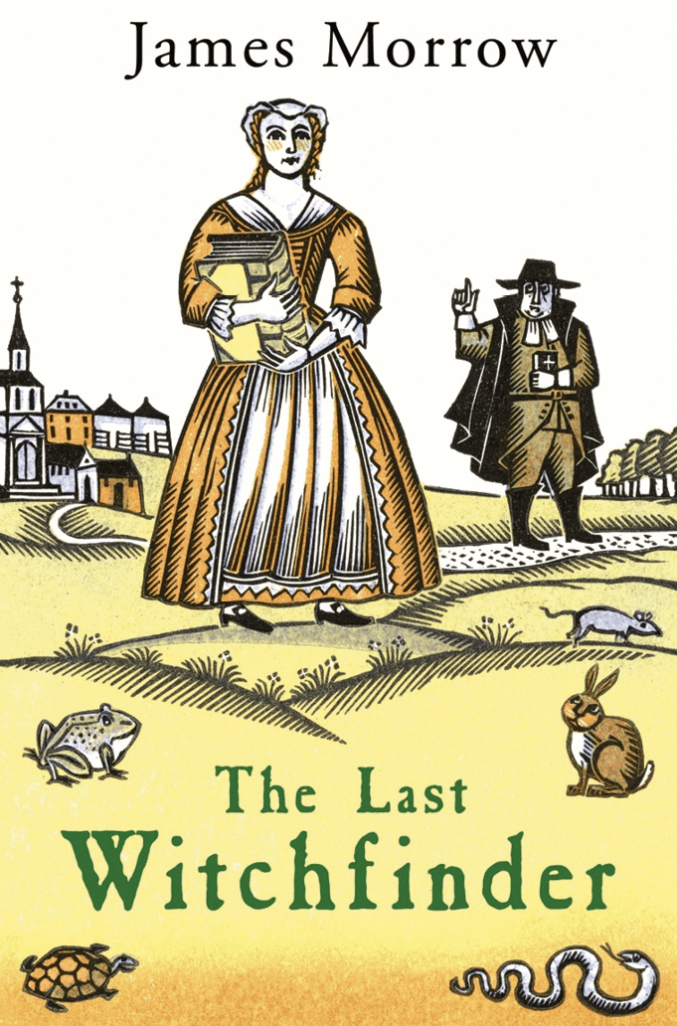
The Last Witchfinder, James Morrow, 2006.
Book selection:
• The Last Witchfinder, novel by James Morrow, 2006.
• The Deer Park, novel by Norman Mailer, 2004.
• The Pursuit of Happiness, novel by Douglas Kennedy, 2001.
• Witch Child, novel by Celia Rees, 2000.
• I Married a Communist, novel by Philip Roth, 1998.
• Silas Timberman, novel by Howard Fast, 1954.
• The Crucible, play by Arthur Miller, 1953
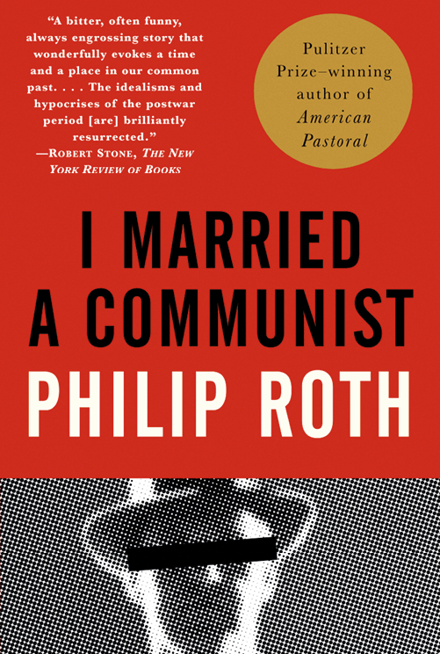
I Married A Communist, Philip Roth, 1998.
Exercise 1: Choose one book from the list and do the following tasks
Find information about your book online (author, date of publication, type of book, summary). Be ready to present it.
To what extent does it present a witch hunt? What is it based on?

Exercise 2: Share your findings with your classmates
What are the similarities and differences between these books?
Which one would you like to read? Why?

ACTIVITY: Prepare and shoot a video review of one of the books listed above or a similar book of your choice. Explain how it illustrates a witch hunt.

