STEP 2 : McCarthyism

Document 1: “The Peacelike Mongoose”
In cobra country a mongoose was born one day who didn't want to fight cobras or anything else. The word spread from mongoose to mongoose that there was a mongoose who didn't want to fight cobras. If he didn't want to fight anything else, it was his own business, but it was the duty of every mongoose to kill cobras or be killed by cobras.
"Why?" asked the peacelike mongoose, and the word went round that the strange new mongoose was not only pro-cobra and anti-mongoose bur intellectually curious and against the ideals and tradition of mongoosism.
-He is crazy, cried the young mongoose's father.
-He is sick, said his mother.
-He is a coward, shouted his brothers.
-He is a mongoosexual, whispered his sisters.
Strangers who had never, laid eyes on the peacelike mongoose remembered that they had seen him crawling on his stomach, or trying on cobra hoods or plotting the violent overthrow of Mongoodia.
-l am trying to use reason and intelligence, said the strange new mongoose.
-Reason is six-sevenths of treason, said one of his neighbours.
-Intelligence is what the enemy uses, said another.
Finally the rumour spread that the mongoose had venom in his sting, like a cobra, and he was tried, convicted by a show of paws, and condemned to banishment.
MORAL: Ashes to ashes, and clay to clay, if the enemy doesn't get you , your own folks may.

“The Peacelike Mongoose”, James Thurber, Further Fables for Our Time, 1956.
Copyright © 1956 by Rosemary A. Thurber.
Reprinted by arrangement with Rosemary A. Thurber and The Barbara Hogenson Agency, Inc. All rights reserved.
To read more about James Thurber, go to www.ThurberHouse.org www.JamesThurber.org

DOCUMENT 2: “It’s okay – We’re hunting Communists”

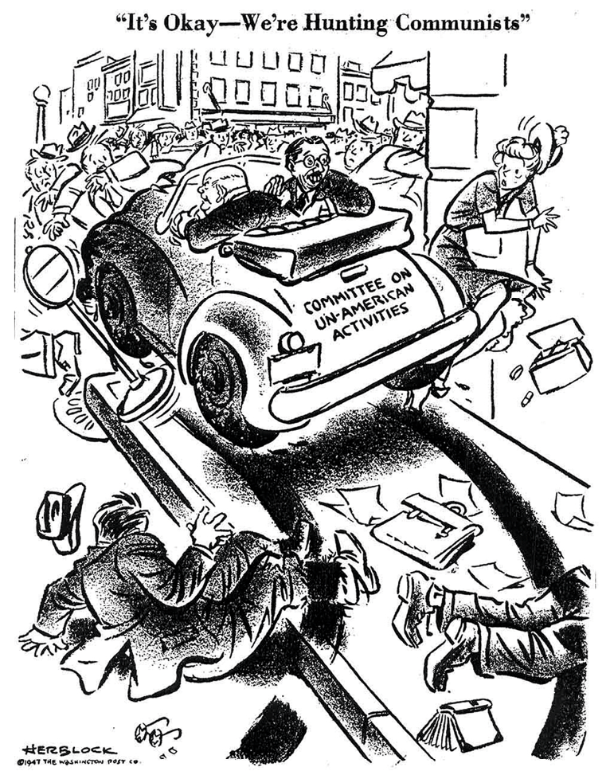

“It’s okay – We’re hunting Communists”, Herblock, 1947.

DOCUMENT 3: Video: Herblock: A Cartoonist's Life (Timing: 8:58 to 10:55)

https://www.c-span.org/video/?52323-1/herblock-cartoonists-life

Choose one document and do the following tasks

Present your document. What form of art is it?

Go online to learn more about its author. How is he related to witch hunts?

Which witch hunt does it relate to? How?

Share your findings with your classmates:

What is similar or different between the two documents?

What are the tools used by each artist to denounce the abuse of power?

ACTIVITY: Write an encyclopaedia entry entitled “McCarthyism in art”. You must use one of the witch hunts you have covered in class so far to illustrate it. (150 words)

