STEP 5 MOVIE CORNER
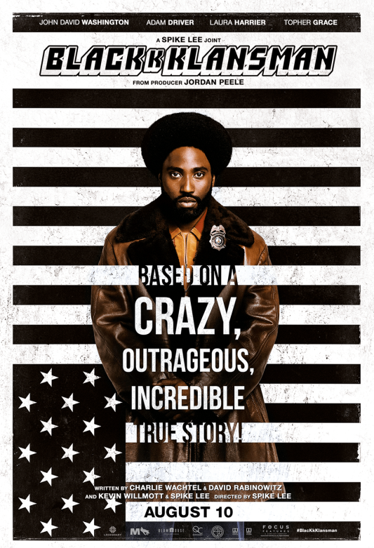
BlacKkKlansman, by Spike Lee, 2018.
Movie selection :
- Red Tails, by Anthony Hemigway, 2012.
- The Butler, by Lee Daniels, 2013.
- Selma, by Ava DuVernay, 2015.
- Barry, by Vikram Gandhi, 2016.
- Hidden Figures, by Theodore Melfi, 2016.
- I Am Not Your Negro, by Raoul Peck, 2017.
- BlacKkKlansman, by Spike Lee, 2018.
- Green Book, by Peter Farrely, 2018.
- Native Son, by Rashid Johnson, 2019.
Exercise 1: Choose one movie from the selection and do the following tasks
- Watch the trailer online and look for information on the Internet. Be ready to present it using visual materials.
- Explain how it deals with relations between Black and White people and how these issues have since evolved.
Exercise 2: Share your findings and learn about the other films
- What are the common points and differences between these films?
- Which one would you like to watch? Why?

ACTIVITY: You are an actor or actress invited to promote your film on a talk show. Speak about the historical issues shown in the film, what they mean to you personally, and their continuing relevance today.

