FINAL PROJECT

The scenario :The Tate Modern is hosting an exhibition dedicated to British and American female photographers.
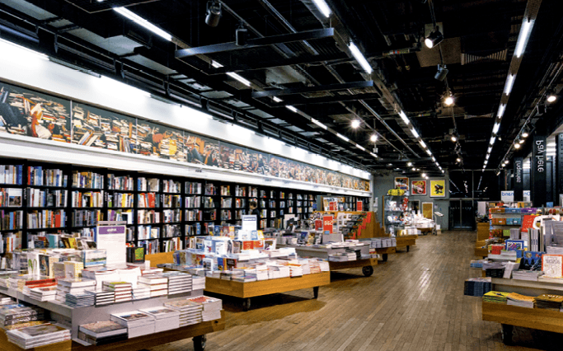
Tate Modern, bookstore, 2012

OPTION 1: Women with Eyes and Cameras: You are the curator of the exhibition. You need to write the foreword of a photography book dedicated to female photographers and their work. (150 words)
- ➜ Prepare your arguments and organize them.
► Méthode Je m'exprime à l'écrit
    - Make sure you can talk about photography, describe and interpret specific pictures..
    - Refer to at least three female photographers.
    - Use examples studied in this unit.
- ➜ Write your piece for the book.
    - Explain how female photographers have a different perspective on the world.
    - Explain why this exhibition is unique.
    - Use the correct possessive adjectives.

OPTION 2: Choose Her! The editorial board of the Tate Modern debates about which female photographers and which of their photographs should be included in your photography book. You are a member of this editorial board. (GROUP WORK)
- ➜ Prepare your arguments and organise them.
    - Select one or two female photographer(s).
    - Select some of her or their photographs and be ready to justify your choice.
    - Explain the reasons why she or they should be in this book.
- ➜ Be convincing!
    - Make sure you can interact.
    - Use “do” to emphasise some verbs when arguing your point.

