Final task: You joined the American Anti- Slavery Society (AASS) founded in 1833 and in which Frederick Douglass was a key leader. You decided to commit to the cause and to become a “station master”.
- Use steps 1 to 5 to revise and make sure you are ready for the task. Then make a list of the useful vocabulary you might need.
- Choose a coherent location (for example a plantation in a Southern State, or a station further North as far as Canada).
- Choose an identity for your character (fictional or real).

Option 1 - Station master memoirs: You have been a “station master” for several years now and have helped many slaves to escape. Write the first page of your autobiography. (150 words)

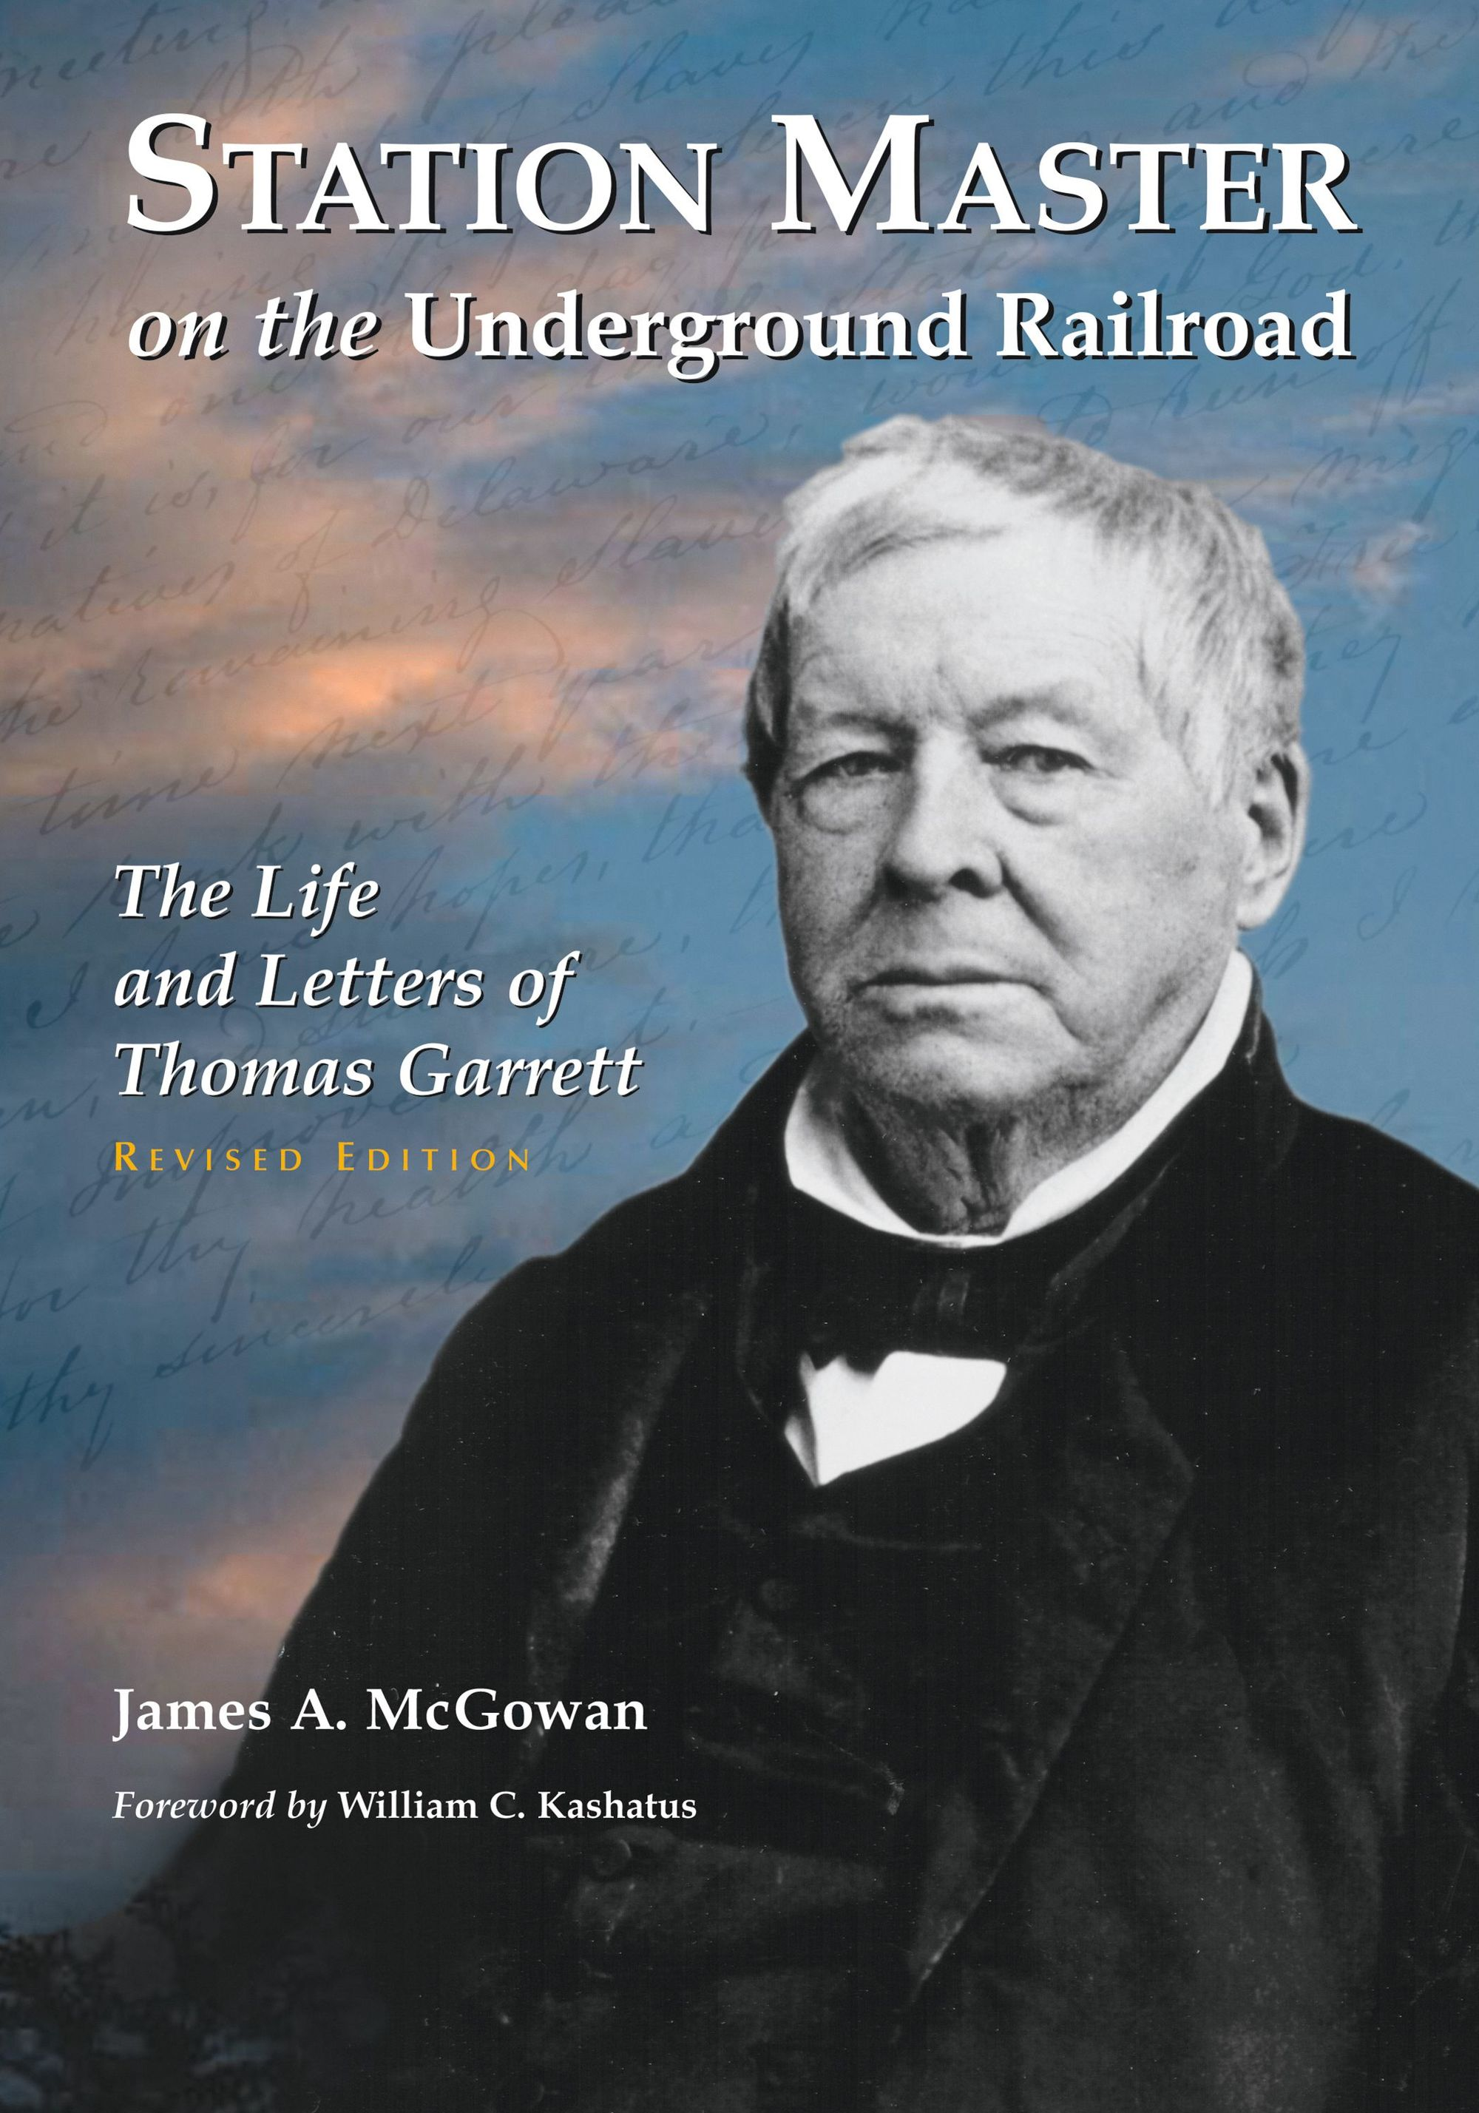
- Prepare your arguments and organise them.
- Write the first page of your autobiography: Write in the first person. Then add feelings to your narrative in order to make it more believable.

Option 2 - Speech delivering: You are a “station master” in the Underground Railroad. You have been invited by the AASS in New York City to make a speech to encourage black and white people to commit to freeing slaves from the South and fight against slavery.

- Prepare your arguments and organise them to build your speech (key elements, arguments, rhetorics).
- Write your speech making paragraphs: Practice reading it, paying attention to the words you will accentuate. Train if necessary by recording it.
- Be convincing! Only write notes so that you are able to look at your audience. Pay attention to your body language as well.
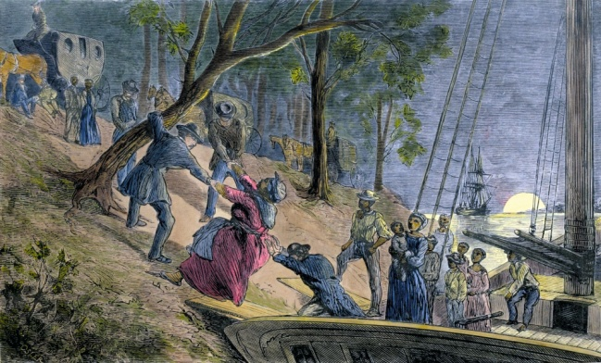

Option 3: Interview and expert: You make a special program about the period of American slavery in which a historian specialized in the Underground Railroad and a descendant of an AASS activist are interviewed.

