Step 4 The reverse underground
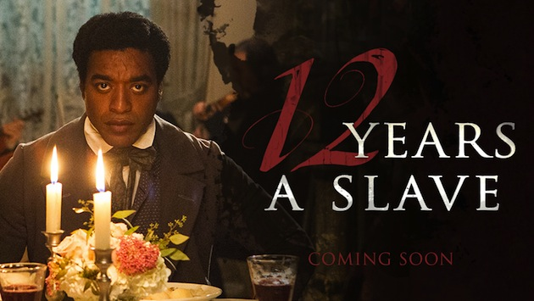
12 years a slave, by Steve McQueen, 2014. From the memoirs of Solomon Northrup, 1853
Watch the trailer
Exercise 1: Present the situation: Where? When? Identify the different identities given to the protagonist
Exercise 2: What happened to the protagonist? How does he react to the changes of setting?
Exercise 3: What advice is given to the protagonist? Is it a good piece of advice, according to you? How was slavery justified by Christians in the extract?
Exercise 4: Discuss. Imagine how Solomon must have felt.
Does it make you feel like watching the film? And if you already have, does this trailer correspond to what is in the film?

ACTIVITY: Black history month celebration:
Choose a historical character. Do some research and prepare an article to participate in the editing of a leaflet to pay tribute to the heroes of the Underground Railroad.

