Step 3: Those who diced with death
Underground is a historical drama TV series produced by John Legend which ran for 2 seasons between 2016 and 2017. It featured Aldis Hodge and Jurnee Smollett-Belt as the main characters Noah and Rosalee. Noah is a slave on the Macon plantation, Georgia, and Rosalee is a house slave.
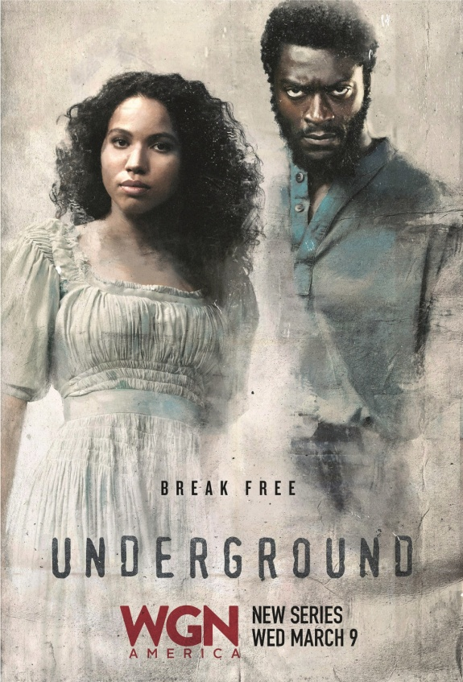
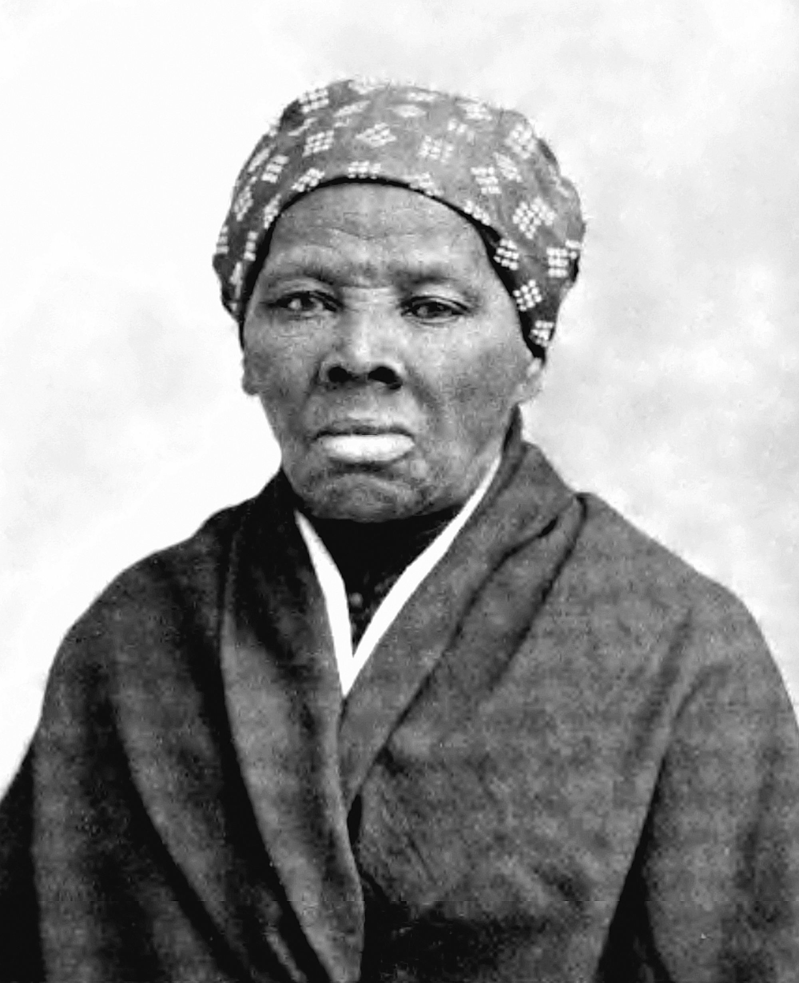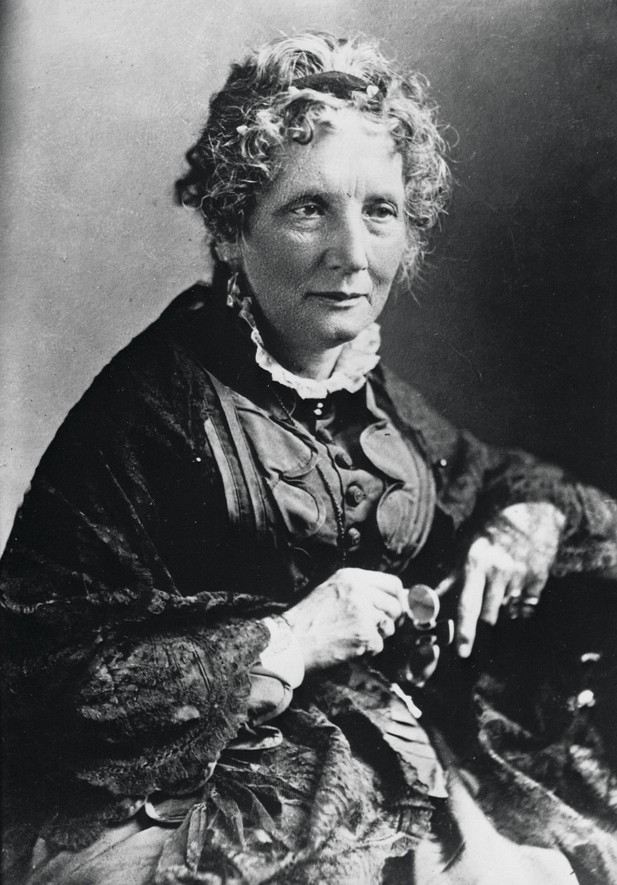
On the left: Harriet Tubman was nicknamed “the Moses of her People”. Herself a fugitive, she helped more than 300 slaves, leading them generally through Delaware to Wilmington and Philadelphia. She embodies the Underground Railway.
On the right: Harriet Beecher Stowe, 1870s-80s, She wrote Uncle Tom's Cabin in 1852.

She said: “Any mind that is capable of a real sorrow is capable of good.”
Harriet Beecher Stowe
This quote was taken from Uncle Tom’s Cabin, probably the most popular novel of the time. Coming from a free state, she was shocked by the inhumanity of slave auctions, which separated families. Her novel grasped the experience of slaves and served the cause of the Abolitionists.
Exercise 1: Look at the photos, watch the videos and recap.
Exercise 2: How did they commit to the abolitionist cause?
Exercise3: Answer: What is the common point between the historical or fictional characters? Justify. Imagine their motivations and their feelings.
Would you have done the same in similar circumstances?

ACTIVITY: Act up a dialogue: Your neighbour is a slaveholder. Without revealing your secret activities as a station master, you have tried to convince him that he should free his slaves. During a secret meeting with other activists, you tell them about the discussion you had with him.

