Step 2 Book club corner

Book selection
Uncle Tom’s Cabin, Harriet Beecher Stowe, 1852.
The House of Dies Drear Virginia Hamilton, 1968.

Bound for Canaan, an Epic Story of the Underground Railroad, America’s First Civil Rights Movement, Fergus M. Bordewick, 2006.

March , Geraldine Brooks, 2006.

Unspoken: A story from the Underground Railroad , Henry Cole, 2012.

The Last Runaway , Tracy Chevalier, 2013.

The Underground Railroad , Colson Whitehead, 2016.

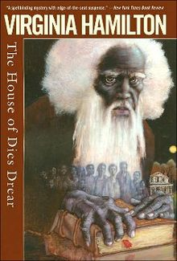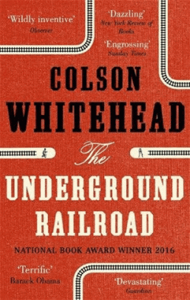
The House of Dies Drear, Virginia Hamilton, 1968. The Underground railroad, Colson Whiteland, 2016
Exercise 1: Search the Internet about your novel. You can read and select some extracts or even read the entire novel available online PDFDrive.com. Be ready to present it briefly. Explain how these books illustrate the Underground Railroad period.
Exercise 2: Answer: What are the common points and the differences between them? Which one do you now feel like reading? Learning more about? Why?
ACTIVITY: Write a review: indicate the characters, the setting, the plot. Then, give your point of view. Why would you recommend this book—or not?

