Step 1: Land of the free?
The Underground Railroad map
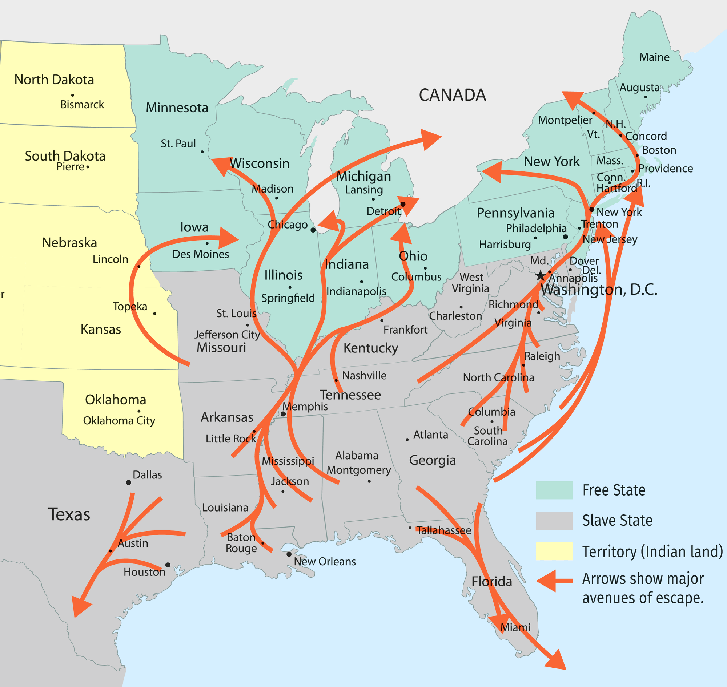

The Underground Railroad, the main routes for the escapees in the 1850s.
Source of the information: National Geographic.
The code of the Underground Railroad:
- Tracks → routes fixed by abolitionist sympathizers
- Stations or Depots → hiding places
- Conductors → guides on the Underground Railroad
- Agents → sympathizers who helped the slaves connect to the Railroad
- Station Masters → those who hid slaves in their homes
- Passengers or Cargo → escaped slaves
- Tickets → indicated that slaves were travelling on the Railroad
- Stockholders → financial supporters who donated to the Railroad
- Freedom Trails → the routes of the Railroad
- Terminal, Heaven, or Promised Land → Canada and the Northern free states

Look at the document
Ex 1: What strikes you? What does it tell you about the Underground railroad?
Ex 2: Listen to the recording. Colson Whitehead tells about the history of the Underground Railroad and the risks taken by the people who took part of it. Be ready to present it.
Ex 3: Why is it called the Underground Railroad?
Ex 4: If it was “the Land of the free”, why did the slaves want to leave the US?
Ex 5: Explain what the Underground Railroad is using the railway code (who, where, when, what).
ACTIVITY: Write an encoded song to help runaway slaves find their way. Think about the content of the verses and the chorus. Use the code studied on the opposite page. You can use the melody of Wade in the Water (see Let's learn! activity 2) or another one.

