BTS exam Paparazzi now using drones to hunt down and photograph stars (262 words)

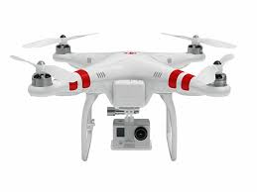
The battle between celebrities and the paparazzi could be going airborne in a new way. Show business photographers now have an eye in the sky. The paparazzi have a reputation of doing whatever it takes to get the shot on the ground - and now, in the air.
What's the concern about paparazzi using drones?
"Well you have a situation where they're able to go anywhere," said Sean Burke.
Burke is director of the Paparazzi Reform Initiative. Last year, with Jennifer Garner's testimony, he helped get a law on the books in California protecting children of celebrities from harassment by photographers. "You have someone with a drone start photographing someone in their backyard, that's a privacy concern, and I think it's a privacy concern for all of us."
California law already protects areas on the ground where people have a reasonable expectation of privacy. Newly proposed legislation would expand that protection to the skies.
"It's kind of like the wild West out there," said Eric Maloney.
Maloney is head of production at Drone Dudes, an aerial cinematography company in Los Angeles. He supports regulations on where drones can fly.
"You shouldn't be allowed to spy on people, to go onto their property, to invade their personal space, simply because you have this new technology," he said.
The Federal Aviation Administration predicts at least 30,000 drones will share the skies in the next five years.

