Step 2 movie corner
Film/TV show selection:
-All The President’s Men, film by Alan J.Pakula, 1976
- Erin Brockovich, film by Steven Soderbergh, 2000.
- Black Mirror, TV show by Charlie Brooker, 2011.
- The Fifth Estate, film by Bill Condon, 2013.
- Mr. Robot, TV show by Sam Esmail, 2015.
- Sense8, TV show by Lana and Lilly Wachowski, 2015.
- Snowden, film by Oliver Stone, 2016.
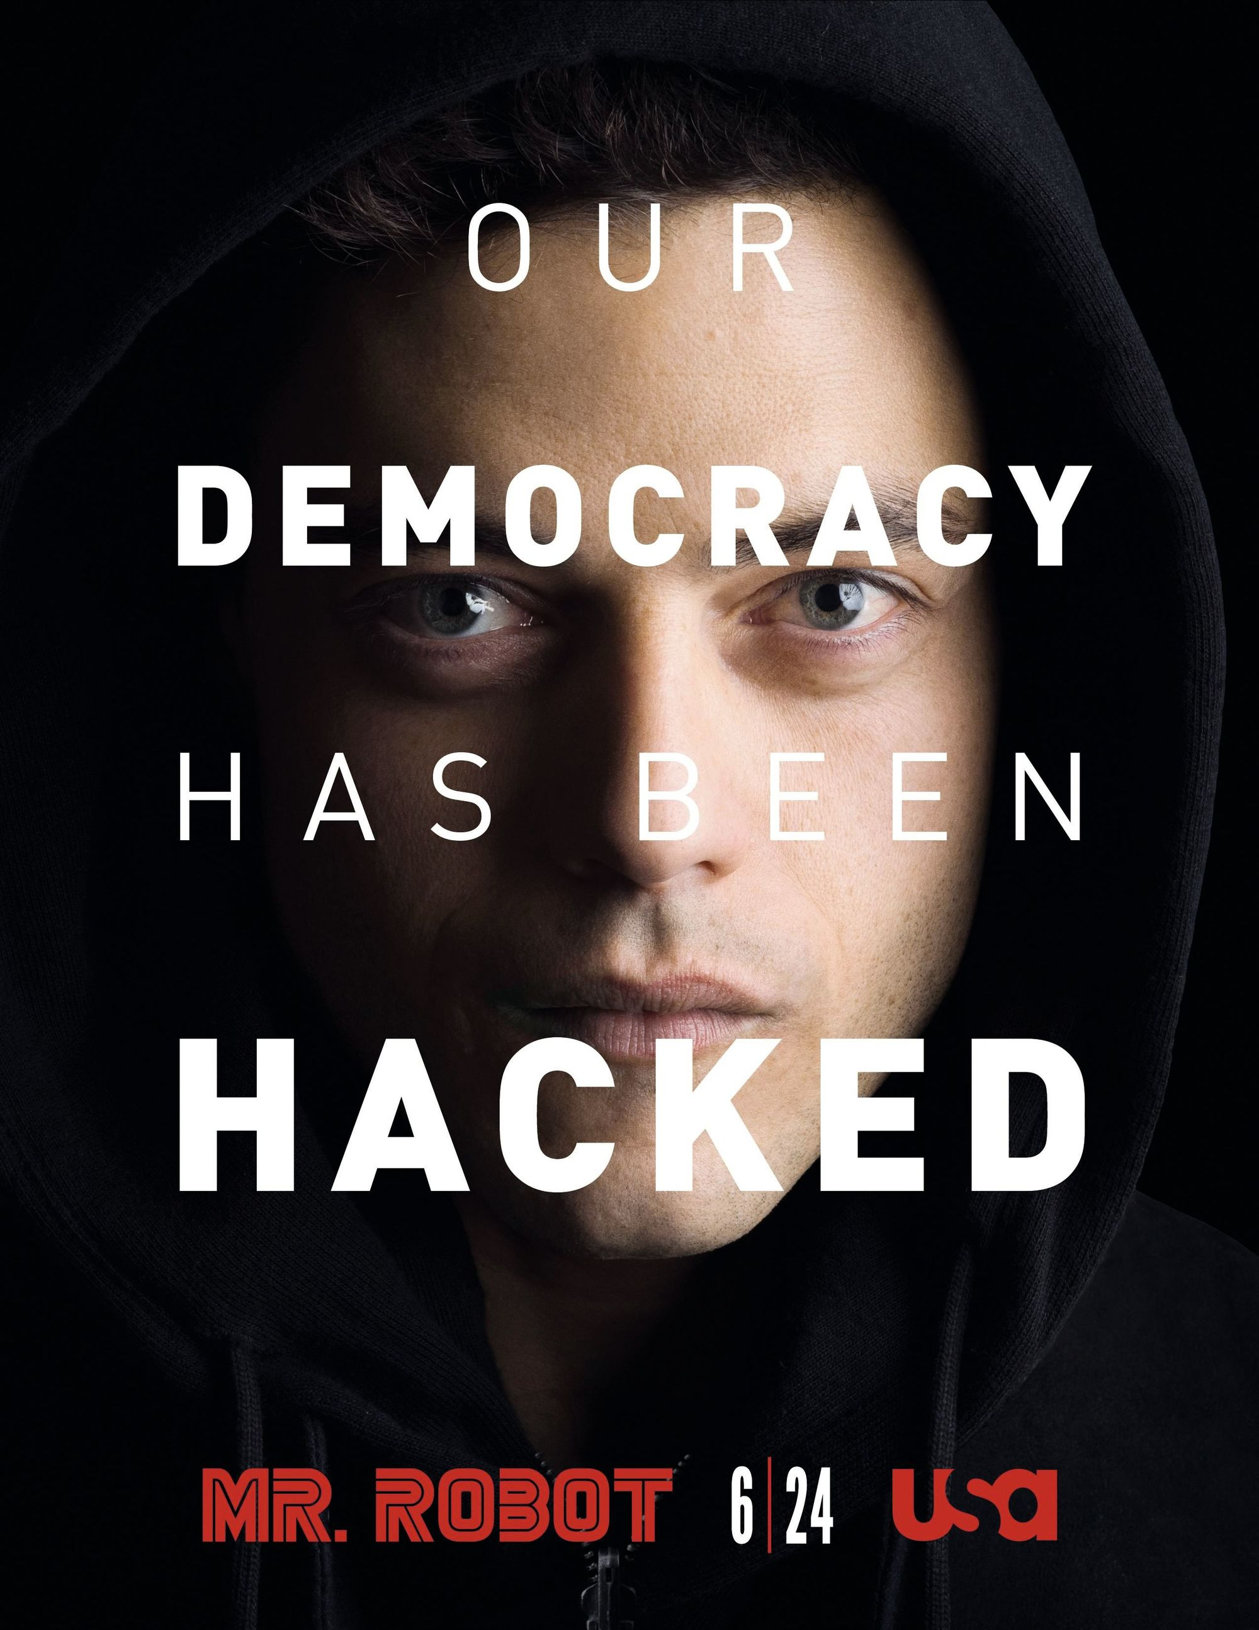
Mr Robot, by Sam Esmail, 2015.

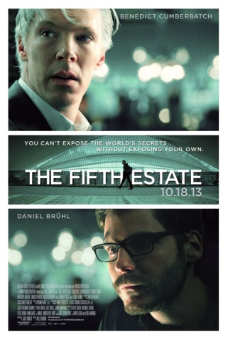

The Fifth Estate, by Bill Condon, 2013.

Exercise 1: Rephrase the taglines of the posters.

Exercise 2: Search the Internet to find information about one film or TV show from the selection. Be ready to present it.

Exercise 3: Watch the trailer. How does it illustrate hacktivism?

Group work + Mediation: What are the similarities and differences between them?
Have you seen this film / TV show? Do you feel like watching it?

ACTIVITY: You attend a meeting of your school's movie club. Choose one of the films you have studied and try to convince the group that it best illustrates what a whistleblower or a hacktivist does.

