Step 2: Bollywood movie corner
Bollywood movie selection:
- Devdas, by Sanjay Leela Bhansali, 2002.
- Bride and Prejudice, by Gurinder Chadha, 2004.
- Guru, by Mani Ratnam, 2007.
- Slumdog Millionaire , by Danny Boyle and Loveleen Tandan, 2009.
- My name is Khan , by Karan Johar, 2010.
- Pad Man, by R. Balki, 2017.

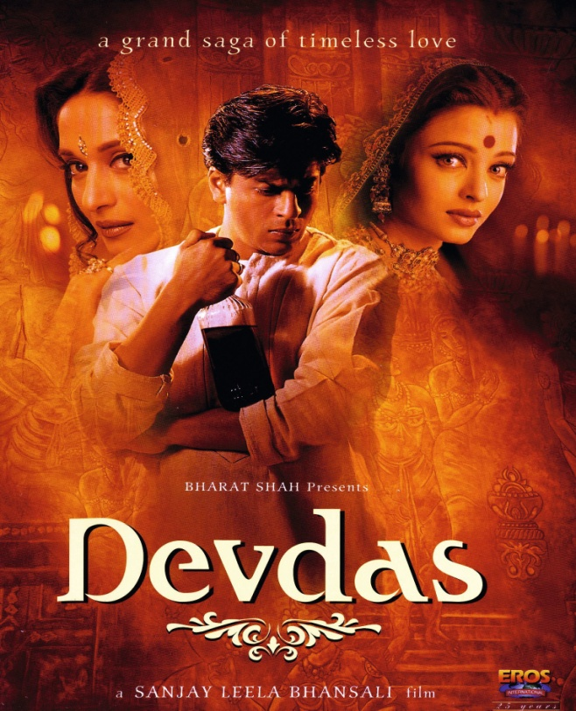
Devdas, by Sanjay Leela Bhansali, 2002.

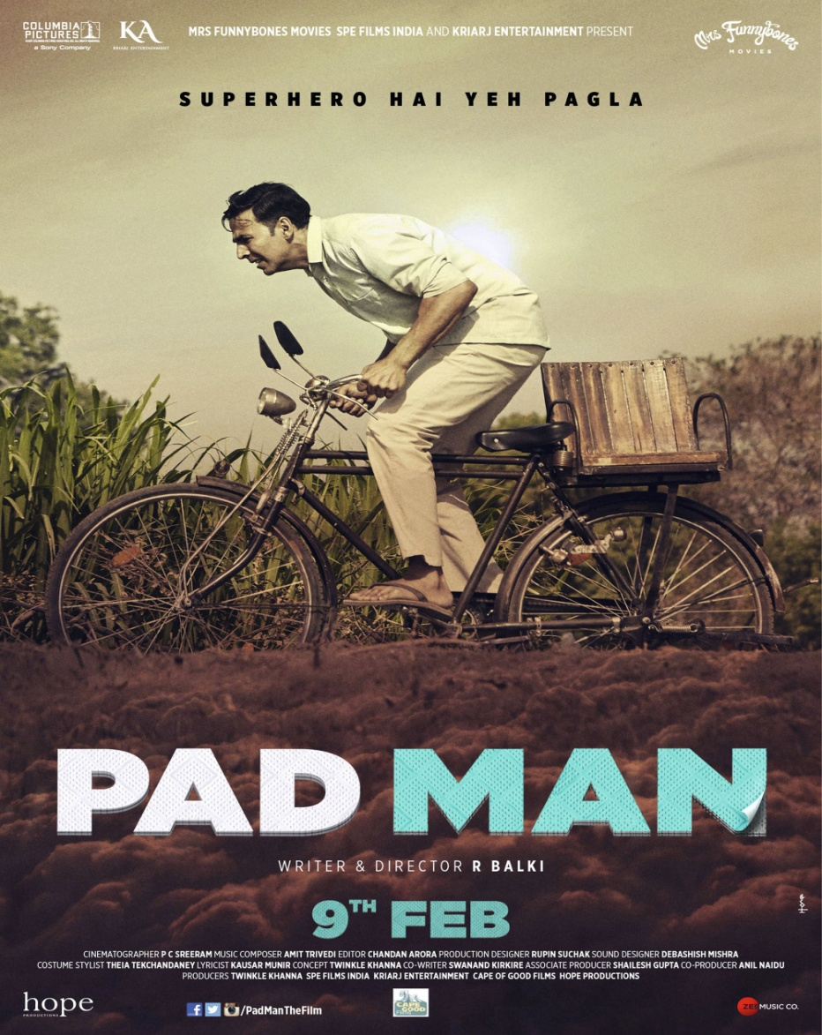
Padman, by R. Balki, 2017.

Exercise 1: Pick one film from the selection. Find information on the Internet and watch the trailer. What are the typical Bollywood ingredients? Write a recap of the plot and the characteristics of the heroes: personality, actions. Is the movie poster coherent with a plot?
Exercises 2: What are the similarities and differences between the films? Classify them in one of the categories: modern India, Indian civil rights, Indian women, impossible love stories, rags to riches.
Decide which movie is the most representative of Bollywood films. Look at the Bollywood movie selection
ACTIVITY: Create the perfect Bollywood movie poster. Imagine a brief plot for your own Bollywood movie, choose the title, your hero or heroine, his or her posture and action. Be ready to present a poster to your classmates and answer their questions.

