TEXT 1: I could have saved someone
- Before you read
Look at the little girl in the photo: give your impression
Considering the title, guess about the content of the text: who, feelings, what, etc

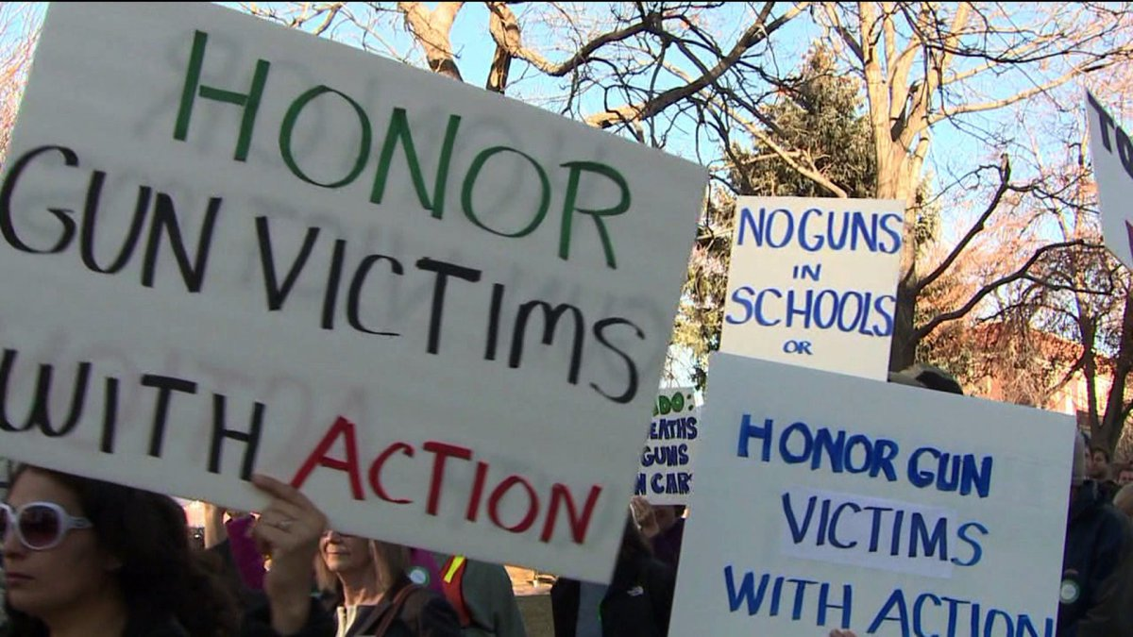
- NOW READ THE TEXT AND CHECK YOUR GUESSES
- RECAP
Pick out information about
-Mr. Allen: his age, his job, where he lives, where he went to school.
-his years at school: what he had in his school bag, what for, how he got it, his friends’ reactions, his feelings at the time.
-what happened later in his school, the consequences.

D) REACT
Explain why Mr Allen says: “My mother saved my life.”
Describe his evolution about guns and explain the title of the text.
Imagine what you would do if you were in Mr. Allen’s class.

MAKE A SPEECH TO CONVINCE STUDENTS NOT TO HAVE GUNS
Mr.Allen visits Thomas Jefferson High School. He delivers a speech in front of the students to convince them not to have guns. Act out his role: write the speech. Then record yourself.

