SLAVERY IN THE ARTS
- PAINTING
In the 17th and 18th century, high-class Europeans liked to have slaves represented in their portraits to show off their wealth and social status.
Slavery has also been an inspiration for artists. Some depicted slaves in their everyday occupations; others – who were abolitionists – denounced the slaves’ conditions and depicted them being bonded, whipped and auctioned.
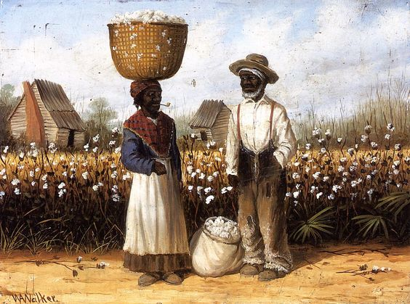

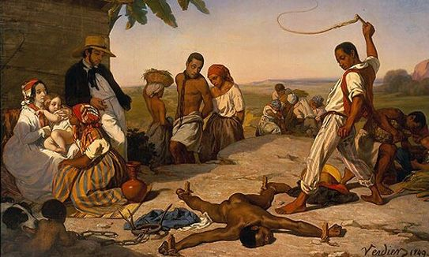

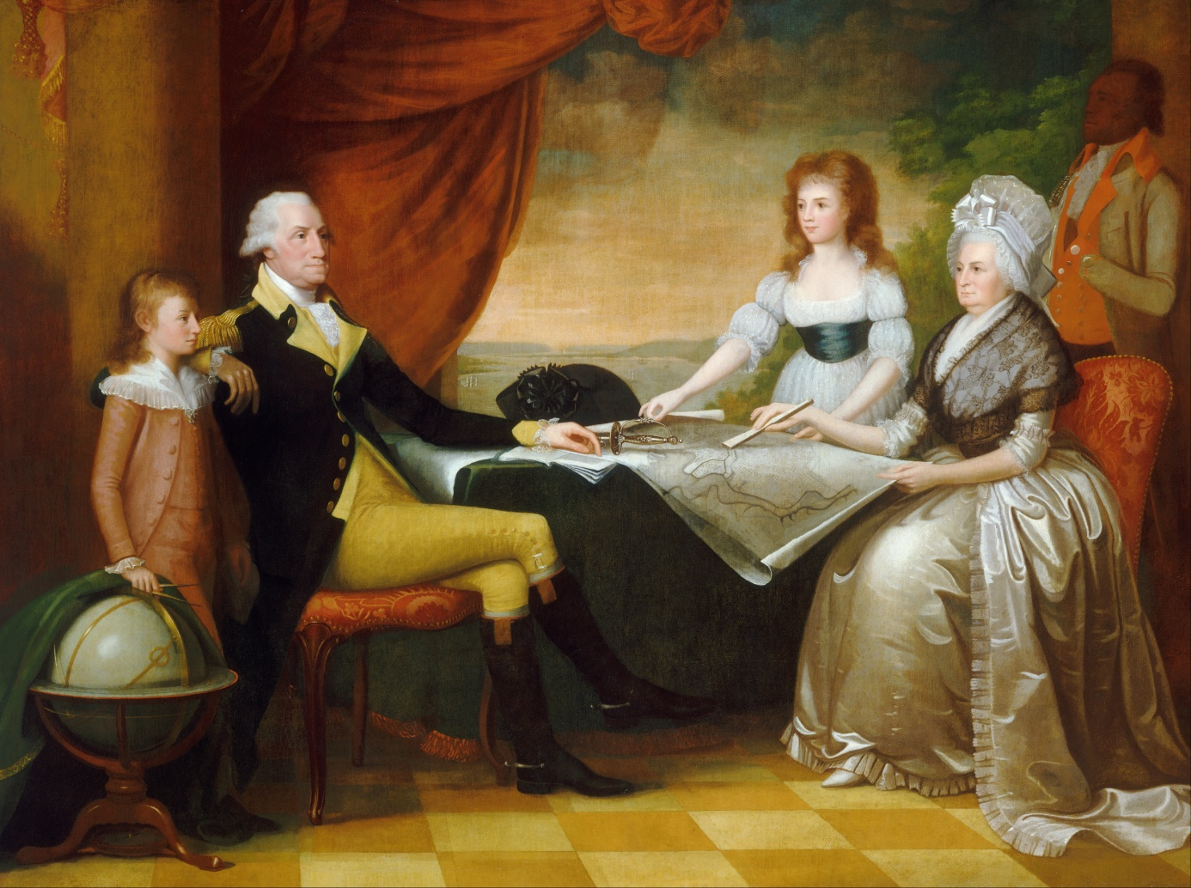
"Washington's Family" by Edward Savage, painted between 1789 and 1796
MUSIC
When African slaves were brought to America, they came along with their singing traditions. Their emotional and physical sufferings made the bonds among them very strong. It is in songs that this powerful sense of community and culture was expressed and that their emotions were conveyed. These songs are divided into several categories: spiritual, work or recreational songs.
- Negro spirituals: Slaves were devoutly religious. They sang some religious songs a cappella, only accompanied by handclapping and foot stamping. Go down Moses
- Work songs: They were sung in the fields, and provided rhythm for repetitive chores. Singing helped workers to synchronise their effort: Hammer song

- Other purposes: Songs had other purposes as well. They might serve to communicate. In some instances, song lyrics conveyed secret messages planning rebellions or disseminating information among slaves. For example, those who were planning to escape would pass songs from one group to another so that everybody knew. Other songs were social political protests. Slaves used many objects to communicate these messages: drums, spoons, plates, tools, and of course their own voices. Slave songs were very important as they helped the slaves remember their history.

Oh freedom, oh, freedom.
Oh freedom over me.
And before I’d be a slave
I’d be buried in my grave
And go home to my Lord and be free.
Literature
The slave narratives - some are accounts of former slaves; others are novels – describe the slaves’ conditions and had an impact on the American public. Some have been adapted into movies.

Uncle Tom’s Cabin by Harriet Beecher Stowe, 1852.
was a bestselling novel in the 19th century and only depicted a somewhat stereotypical picture of black slaves that inspired the abolitionist struggle.

Incidents in the life of a slave girl by Harriet Jacobs, 1861
This autobiographical account chronicles the odyssey of Harriet Jacobs who escaped from a life of servitude in North Carolina to liberty and reunion with her children in the north.

The confessions of Nat Turner by William Styron, 1992
Styron wrote a story of a 1831 revolt, led by a remarkable negro preacher named Nat Turner, an educated slave.
A Long Way from Home by Connie Briscoe, 2000
explores the lives of three generations of African Americans living at Montpelier plantation in Virginia and their relationships with their white masters.
A Mercy by Toni Morrison, 2008
This novel is set in America around 1690. Slave labour sustains farming and trade. A mother prefers to cast off her daughter in order to save her .
Movies
Hollywood has long been reticent to tackle the subject of slavery but in recent years several movies have attracted the attention of the audience to the horrible reality of slavery.

Gone with the Wind (Victor Fleming, 1939), one of the first American movies, depicted slaves as happy, jovial, in really demeaning stereotypes.

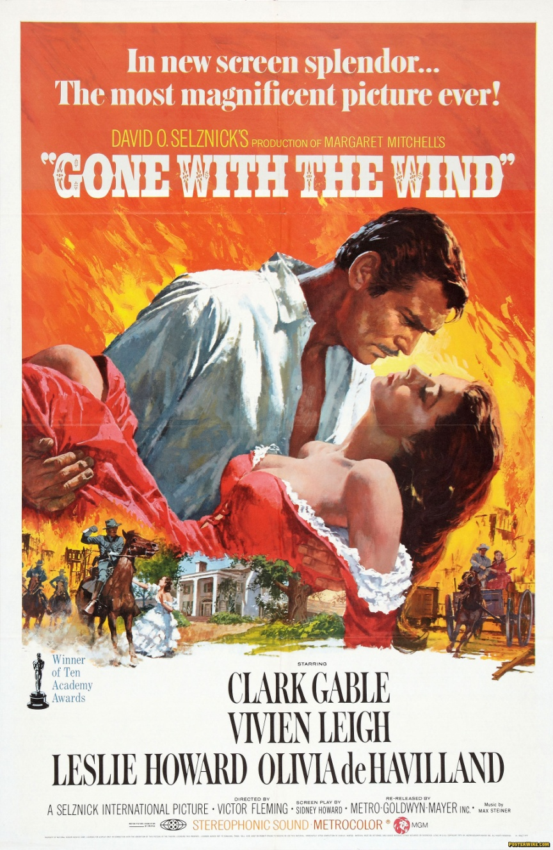

Roots (1977) a popular TV series related the dramatic plight of slaves and probably changed Americans’ perception of their own history. It is based on the bestselling novel by Alex Haley Jr. The movie depicts Haley’s ancestral line from slavery to freedom.
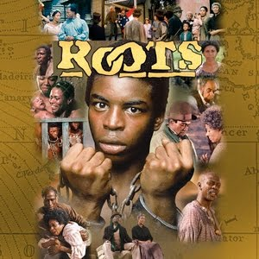

Amistad ( Steven Spielberg, 1997) presents the transatlantic slave trade. It looks at the middle passage, the journey on a slave ship across the Atlantic Ocean. Countless millions of Africans died on this long tortuous journey from illness, starvation and brutality. Much of the story involves a courtroom drama about the free man who led the 1839 revolt.

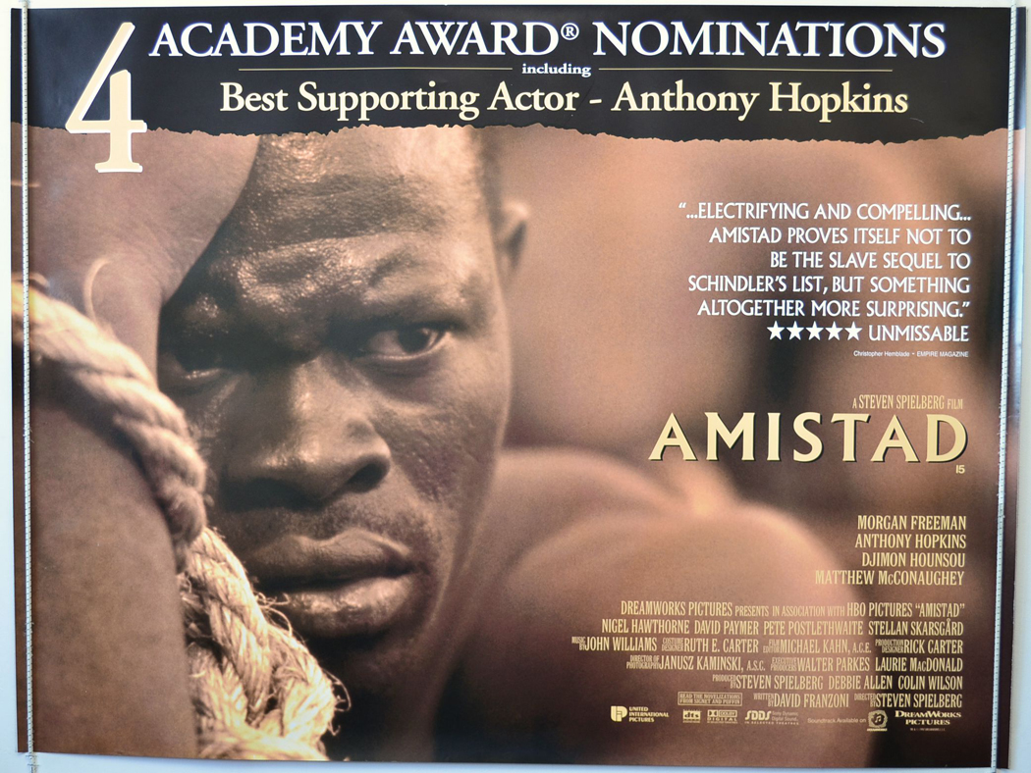
Beloved (Jonathan Demme, 1998) is based on the Pulitzer Prize winning novel by Toni Morrison, this movie focuses on the experience of a black woman slave, named Sephe, who escaped to Ohio from a Kentucky plantation in 1856. When slave hunters find her in Ohio she kills her daughter and attempts to kill her other children to prevent them from going back to Kentucky as slaves.
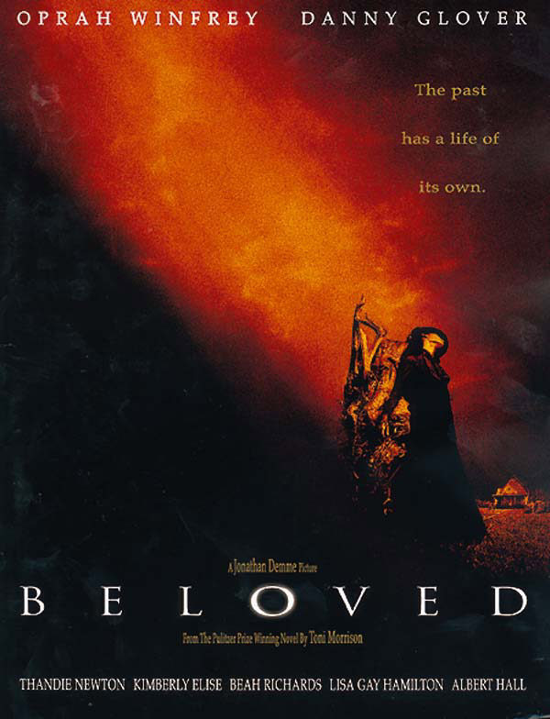

Django Unchained. (Quentin Tarantino, 2012). This movie is loosely based on the life of Bass Reeves, the first African-American federal marshal in the United States. Django is an escaped slave who works to purchase his wife’s freedom.

