TEXT 1 : TWELVE YEARS A SLAVE
- BEFORE YOU READ
Look at the pictures and recap what you know about Solomon Northup.
Find out on the Internet where Saratoga is situated and if it was in a free state or a slave state.
Imagine what the situation is in photo 2.
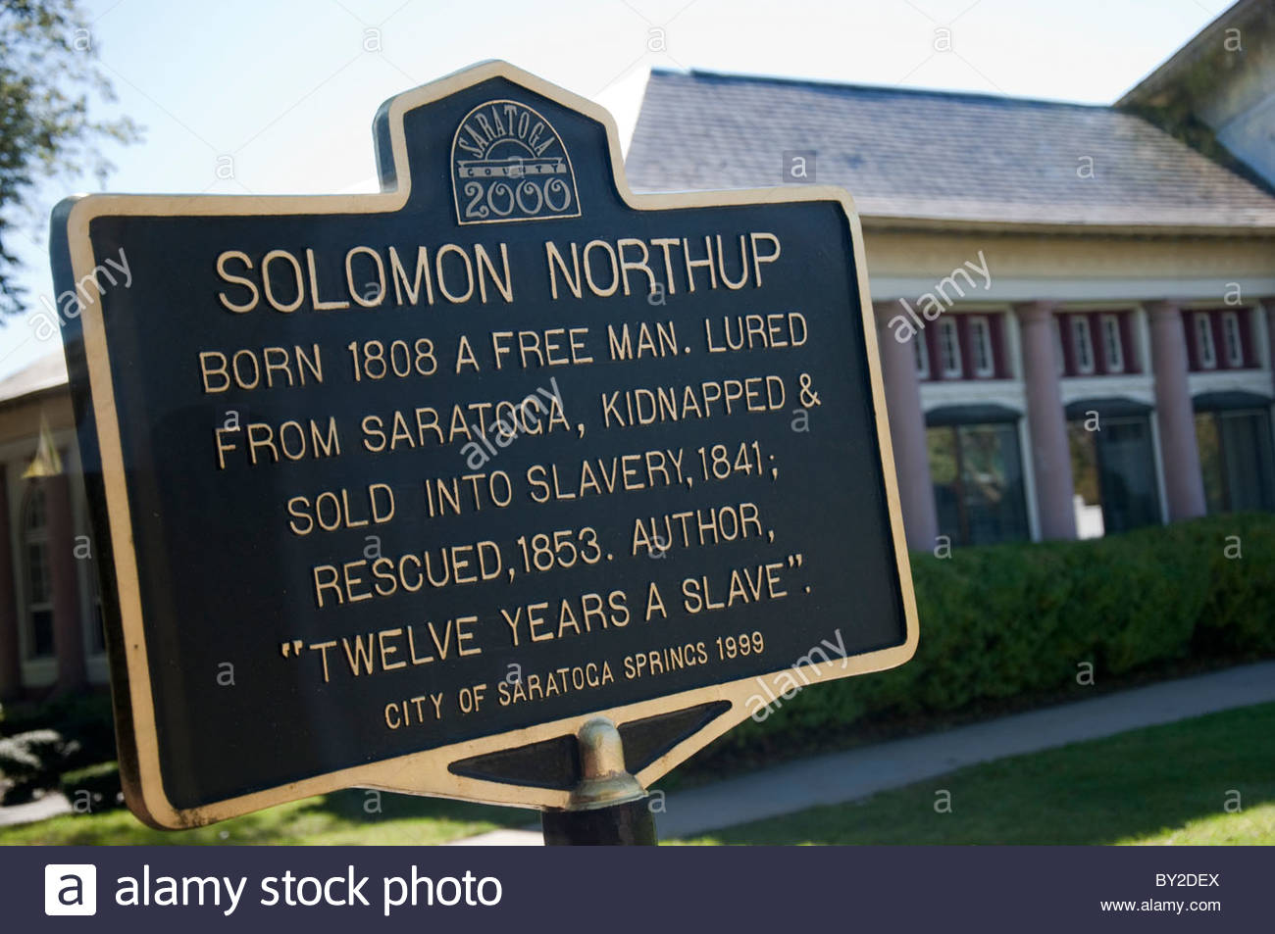

- READ THE TEXT AND CHECK YOUR GUESSES
- RECAP
Talk about the situation and the two characters’ relationships.
Explain why two places – a city, Saratoga; and a state, Georgia – are mentioned ad what the two men disagree on.
Talk about the two characters’ feelings.
Explain what Radburn’s role is.
Find in the text a definition for “the paddle and the cat o’nine tails.”
- REACT
Say what the phrase “human stable” implies.
Say what you think of Northup’s personality. Quote from the text to justify.

- SUM UP THE TEXT
MAKE A PRESENTATION ABOUT SOLOMON NORTHUP
Search the Internet for information about what happened in the life of Solomon Northup after he got to freedom in 1853. Then make an oral presentation of his biography.

