LISTENING : When slaves arrived in the Americas
- BEFORE YOU LISTEN
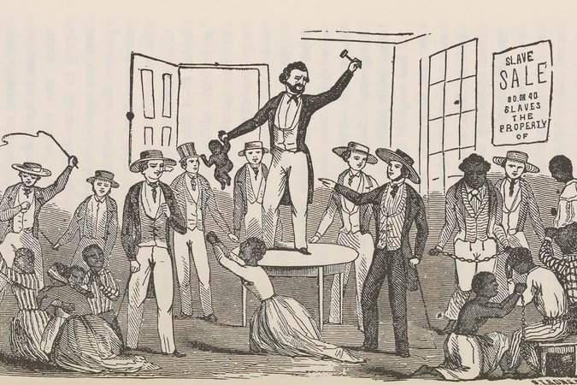
A slave auction
The slaves were brought in early so that buyers who desired to inspect them might enjoy that privilege. The negroes were examined with as little consideration as if they had been brutes; the buyers pulling their mouths open to see their teeth, pinching their limbs to find how muscular they were, etc.
The New-York Tribune, 1859
Judging from the introduction, the picture and the caption, guess what you are going to hear.
Find out where the island of Barbados is.
- NOW LISTEN TO THE DOCUMENT AND TAKE NOTES
- RECAP: Talk about
-what happened to the slaves when they arrived in America;
-how the slave sales took place and what the consequences were;
-the slaves’ conditions;
-Olaudah’s feelings.

- REACT
Explain the fact that many slaves were branded with their master’s name.
Imagine the consequence on the slaves of the treatment they had.
- SUM UP THE DOCUMENT IN FRENCH

RECORD A TESTIMONY
Olaudah Equiano wants to leave a recording to his grandchildren to tell them about his condition when he was a slave. Work in pairs to prepare his presentation in note form. Record yourself.

