VIDEO THE LEGACY OF SLAVERY
- BEFORE YOU WATCH
Talk about the life of slaves on cotton plantations.
Say how Americans feel about movies that deal with slavery.
Explain the title of the document.
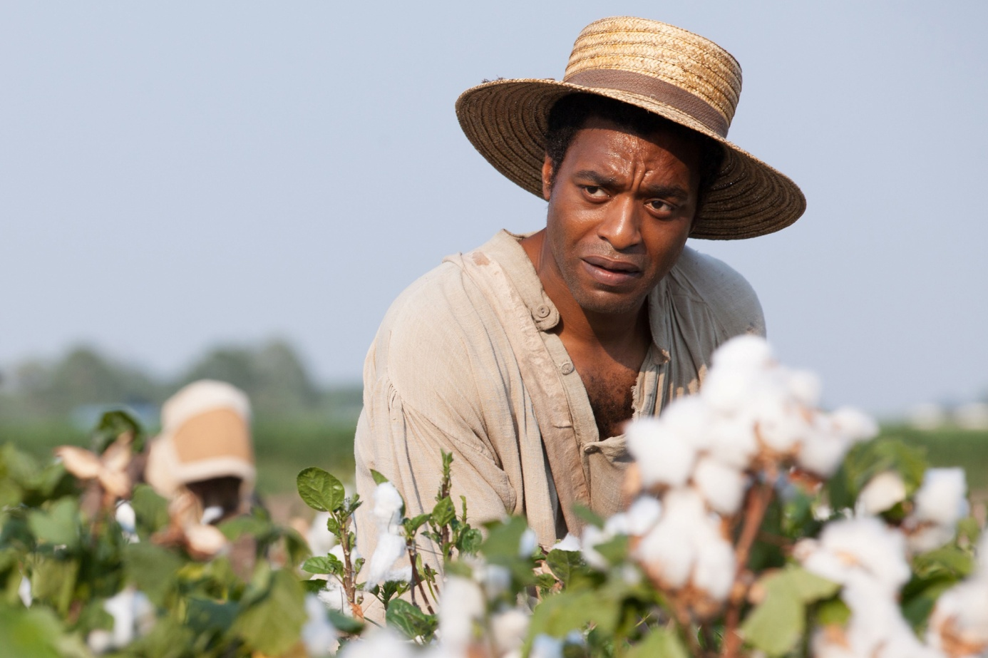
Steve McQueen, Twelve Years a Slave, 2013
Large numbers of slaves were purchased to work on cotton plantations.
- NOW WATCH AND SUM UP WHAT YOU HAVE UNDERSTOOD
- RECAP
Explain what the impact of films about slavery has been in America and the changes that have occurred.
Say what the key question about slavery legacy is.
List the different opinions that re presented in the document and explain these people’s arguments.

D) REACT
Say if you would be interested in seeing a movie about slavery or not. Justify

- SUM UP THE DOCUMENT IN FRENCH
PRESENT A MOVIE: In groups, search the web to select a movie dealing with slavery and prepare a presentation. Give your presentation to the class.

