ART AND POWER: A Never-Ending (Hi)story?

Problem: How can art be used to denounce witch hunts?

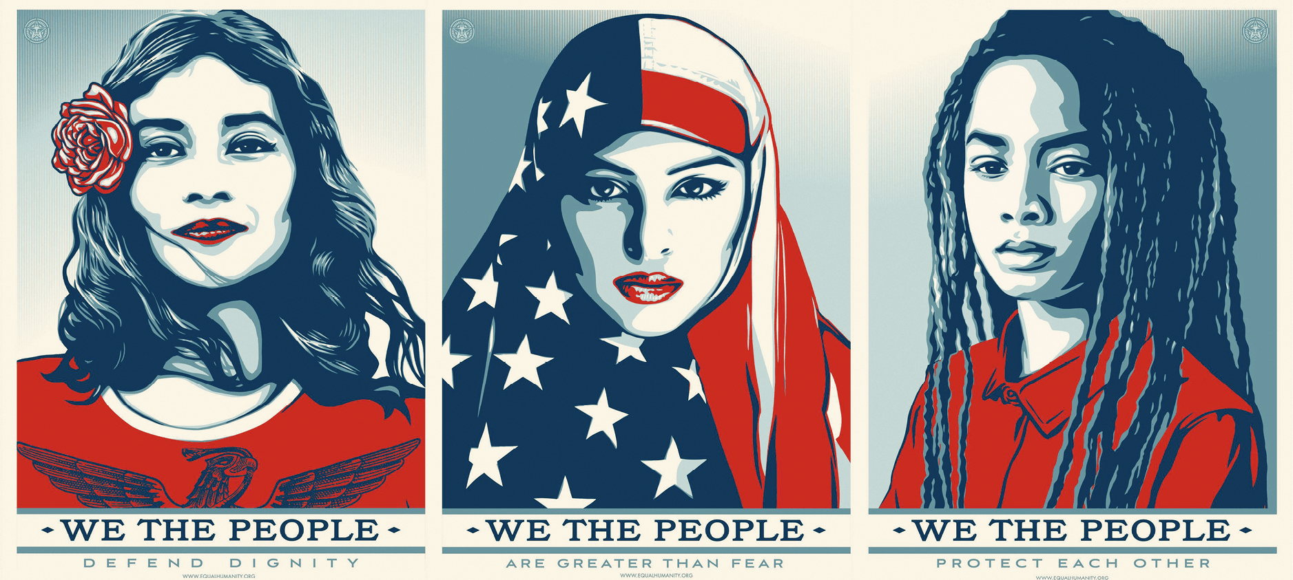

“Defend Dignity” (representing Maribel Valdez Gonzalez), “Greater Than Fear” (representing Ilhan Omar), “Protect Each Other” (representing Menelik), We The People campaign, Shepard Fairey, 2017.

Exercise 1: Look at the image and answer the following questions:
- What and who do they represent?
- What is the message of the artist?

Exercise 2: Watch the video and do the following tasks:

https://www.youtube.com/watch?v=jJJLy5_DlqY&feature=youtu.be
- Make a mind map to recap
- ANSWER: What is the link between the image and the video?

Exercise 3: Discuss these brainstorming questions with your classmates.
1) Have you ever heard of witch hunts in the U.S.A?
2) What do witches stand for?

Exercise 4: Read this idiom and rephrase it in your own words. Give examples.

As rumor has it: This phrase indicates that the speaker is about to pass on a surprising fact they have heard. Rumors are usually unconfirmed, and are often spread to hurt the people they concern. With today’s technology, a rumor can go viral online in a matter of minutes.

